THE SCORESHEET
A quick overview
Your responsibility is to record goals and exclusions.
The referee will indicate to you which cap number has just been kicked out or scored a goal.
Count the digits up to 9, and then a clenched fist is 10 plus digits after that. See picture below lifted from Water Polo Australia manual.

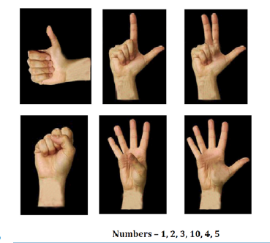

Exclusions are recorded by crossing out one of the three boxes to the left of the player’s name. If a player receives 3 exclusions they are out for the rest of the game. In theory this is where you would raise a red flag.
For goals simply record it next to the players name in the box appropriate to whichever quarter you are in. Use Roman numeral style.
At the end of each quarter total up the goals scored at the end of the column. Total the goals scored per player in the rows at the end of the game.

THE CLOCK

A quick overview and sample

The clock itself is usually set up by the referee.
If you need to set up times, set 7 minutes per quarter, one minute quarter breaks and 2 minutes half time.
We will be playing 7 minute quarters LOCAL time. This means that the game clock timing the 7 minute quarter is not stopped. The game is managed via the 30 second shot clock.

[If we were playing 5 minute quarters NATIONAL time. This means that the game clock timing the 5 minute quarter is stopped along with the shot clock every time the whistle blows. The game is managed via the 30 second shot clock.]

The shot clock, set to 30 seconds, is the amount of time the attacking side can have "playing" possession of the ball. This means each time there is a foul the shot clock is stopped and is restarted as soon as the player plays the ball. So, keep an eye on the referee and if they blow the whistle for a foul STOP the clock. As soon as the ball is played START the shot clock.

The shot clock is reset to 30 seconds [simply by pressing the RESET button] when any of the following occur:
- A goal is scored. Press STOP, RESET and then when the game is restarted from the half way line press START
- There is a clear change of possession. A fumble around with it being unclear who has the ball is not a change of possession. It's normally fairly obvious when there has been a change of possession
- Every shot at goal. This is important. If a player shoots it is reset immediately, and if it hits the post and rebounds, reset the shot clock again when a player regains possession of the ball.
- A player is excluded. (Also for 16&U press the player out button). This will time the 20 seconds the player is excluded for, then a buzz/noise will occur. Need to raise the white or blue flag to match the cap colour of the excluded player. (only after they have reached the exclusion box and they or a substitution player is ready to re-entered the field of play).

- A 2 metre is given ‐ this occurs when the ball touches or goes over the goal line and the goalie was the last person to touch the ball or a defending player deliberately sends the ball over the goal line.
- A 5 metre penalty is awarded.
- Whenever the referee signals by pointing a finger upwards and making a circular motion. (normally for a ball under which the timekeeper may not realise).
- Neutral throw awarded. (Jump ball).
- Important – DO NOT RESET shot clock or hit the player out button if there is a double exclusion of players.

- Keep the goal count up to date as the game progresses (Score up & down buttons) white and blue.

